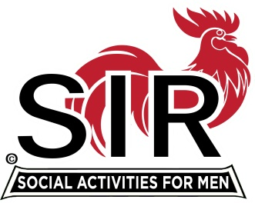

Las Trampas Branch 116
Luncheon Meeting Agenda
July 18th, 2022, 10:30 AM

10:30 Check-in
Greeters at the door – Paul Ramacciotti, Alan Pope
Vaccination Check table – Kevin Donahue
Treasurer Table – Alan Fitzgerald, Al Satake
Name Tags Table – Mike Schneider
Raffle Table – Ben Bryce

11:25 Five Minute Call
11:30 Call to order; Welcome back to all – Big SIR
Pledge of Allegiance – Mac McLoughlin
Chaplain – Bill Foulds
Sunshine Report – Matt Arena

11:40 Story Teller – Mac McLoughlin
11:45 Member & Branch Updates - Fred Wachowicz, Roger Craig

11:45 Salad Served
12:00 Lunch
12:10 Activity Committee Announcements Jeff Johnson
12:20 Introduce Speaker, Mr. Paul Ruff –Al Farbman
13:05 Speaker Thank You – Little SIR Roger Craig
13:10 Raffle Drawing – Ben Bryce
Birthday Drawing– Little SIR Roger Craig
13:20 Sing Happy Birthday – Music – Paul King
Sing God Bless America - Paul King

13:25 Closing Remarks – Big SIR
13:30 Adjourn; Next Meeting, August 15th
************************************************

